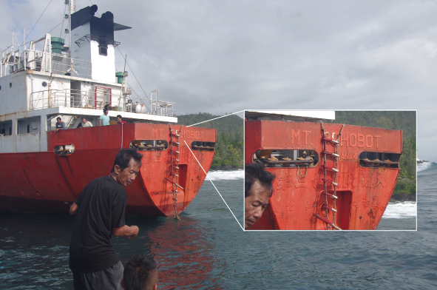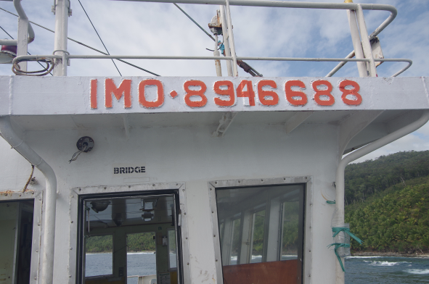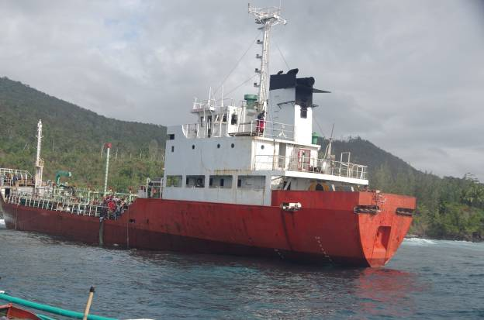

MT REHOBOT UPON APPROACH OF INVESTIGATION TEAM

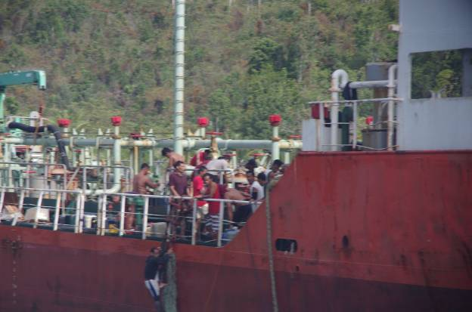

LOOTERS TAKING DIESEL FUEL FROM MT REHOBOT

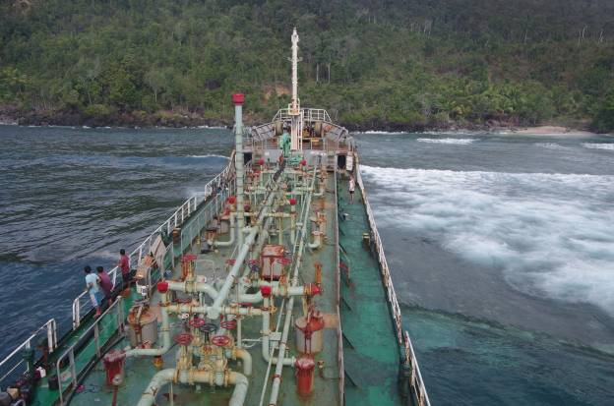

MAIN DECK OF MT REHOBOT

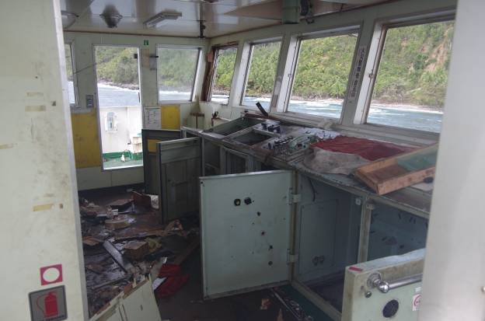

BRIDGE HAS BEEN RANSACKED BY LOOTERS

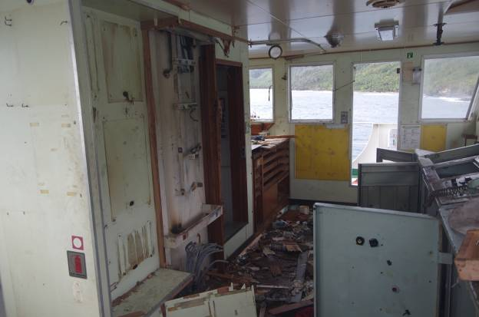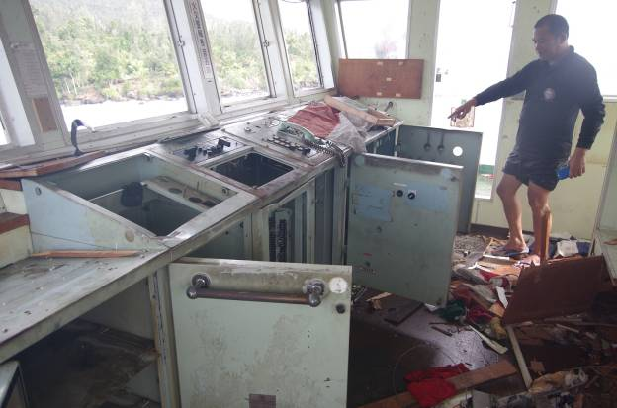

ALL NAVIGATIONAL EQUIPMENTS WERE TAKEN FROM THE BRIDGE

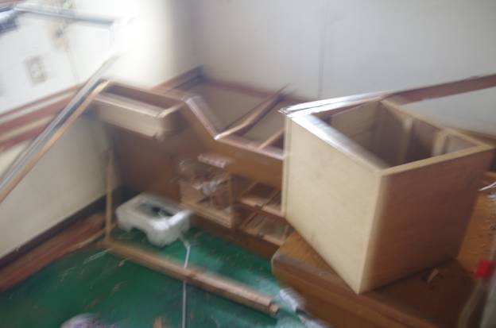

CREW CABINS OF MT REHOBOT

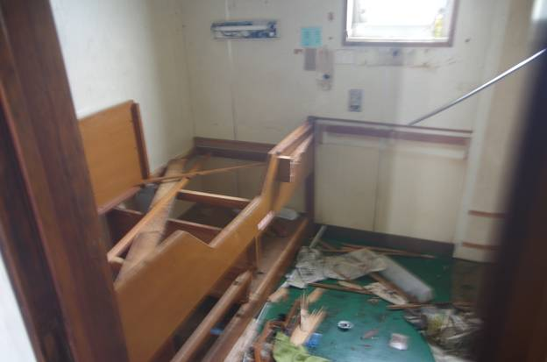

BUNKS AND CABINETS HAVE BEEN TAKEN AND VANDALISED

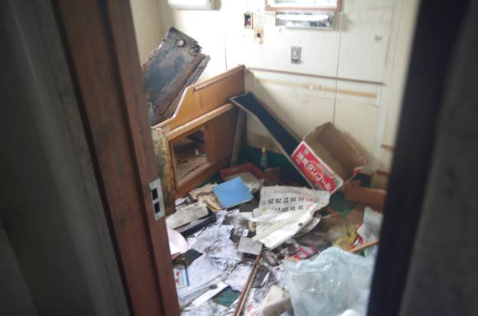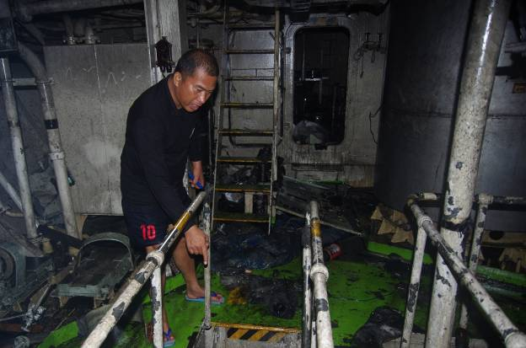

ENGINE ROOM WAS ALSO RANSACKED

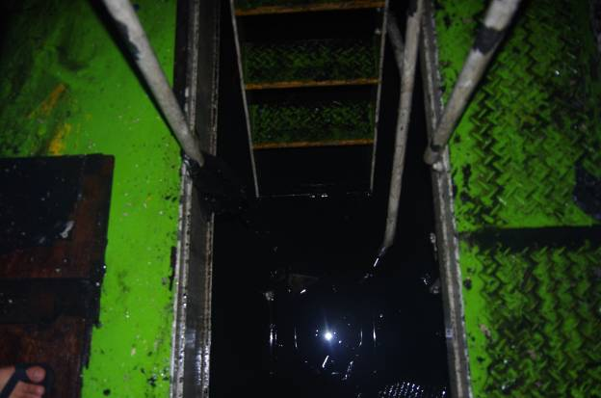

ENGINE ROOM WAS FLOODED WITH A MIXTURE OF OIL AND WATER

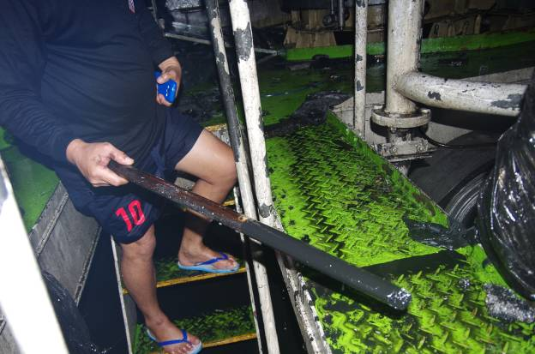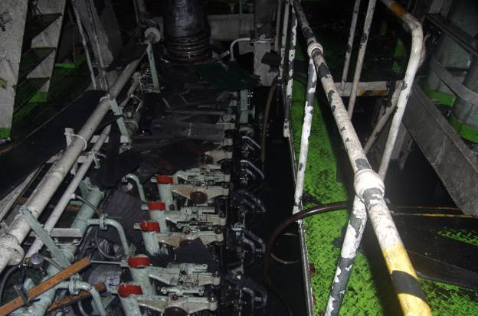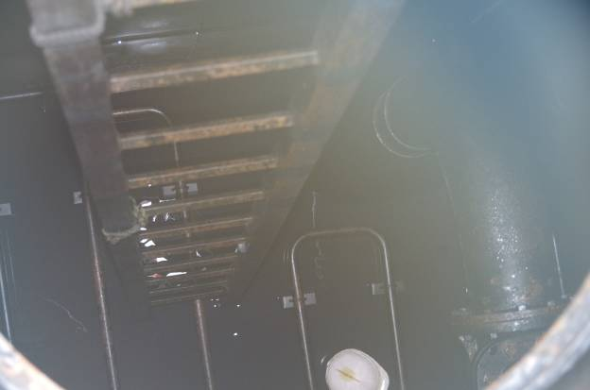

FORWARD TANKS HAS AN ESTIMATE OF 1 FOOT DEEP FUEL LEFT

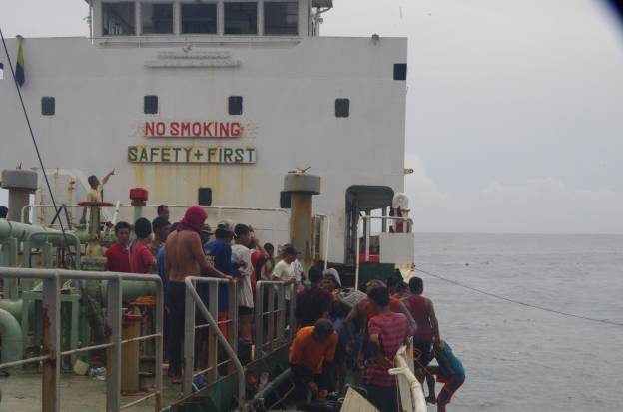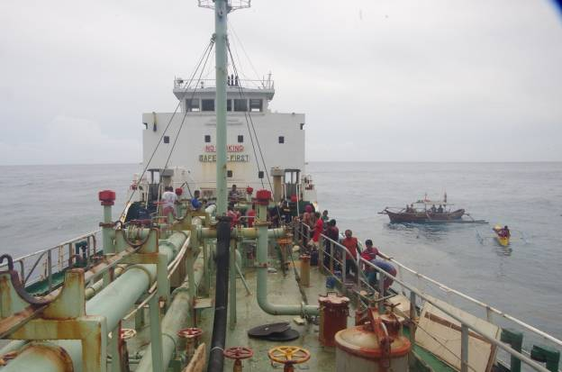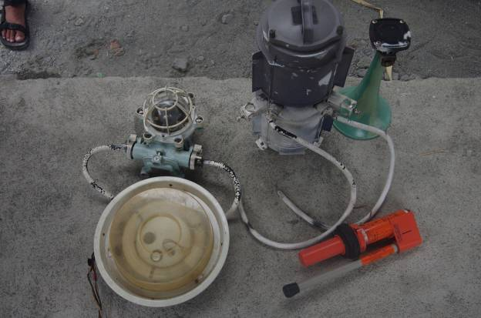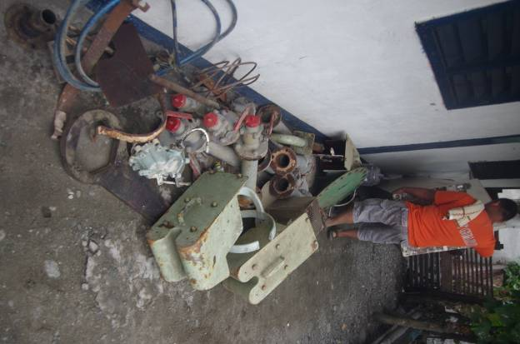

RECOVERED ITEMS FROM LOOTERS OF MT REHOBOT